THE CO-OPERATIVE UNIVERSITY OF KENYA
P. O. Box 24814-00502 Karen, Kenya
Telephone: (020)-2430127/2679456/8891401 Website: www.cuk.ac.ke/dacsis
DIRECTORATE OF ALUMNI, CAREER SERVICES AND INTERNATIONAL STUDENTS

TO: ALL STUDENTS REF: CUK/A/190(A)

FROM: DIRECTOR, DACSIS DATE: 24TH September, 2021

RE: UPDATING OF ATTACHMENT DETAILS ON THE STUDENTS PORTAL

As of January 2021, all students on attachment are required to upload their attachment details online through the students’ portal. Students are required to follow the following steps to successfully update their details:
Step 1: Log into your student portal account by using your registration number and password
Screen 1: Log on Screen
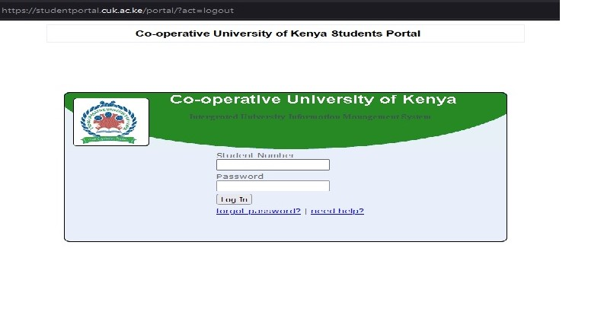

Step 2: Click on Field Attachment
Screen 2: The “Field Attachment” Button
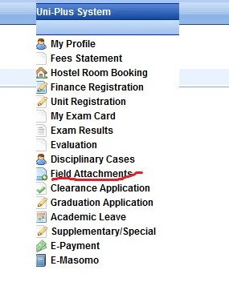
Step 3: Click on Print attachment letter. You will need the attachment letter to introduce yourself to the attaching organization.
Screen 3: The “Print Attachment Letter” Button
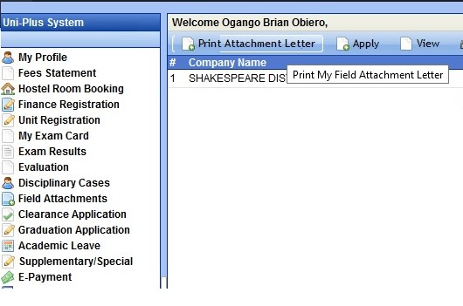
Step 4: Click on apply. A window will open that allows you to feed in your attachment details. Ensure you save and apply for evaluation to successfully complete this step. Your organization details will then appear when you click on “Field Attachment”.
NB: Only students who have registered for Industrial Attachment as a unit will be able to access this page.

Screen 4: Attachment Details Page
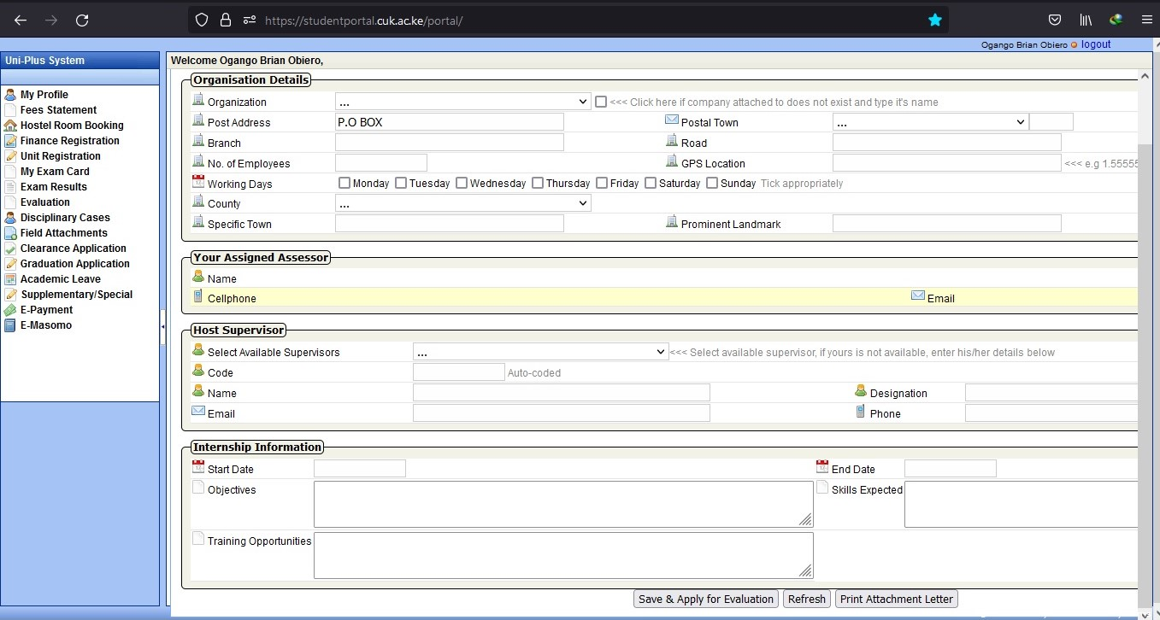
NB: Do not fill the “Your Assigned Assessor” section, this section will be automatically filled once the University assigns you an assessor.
Screen 5: Post Saving Attachment Details Screen
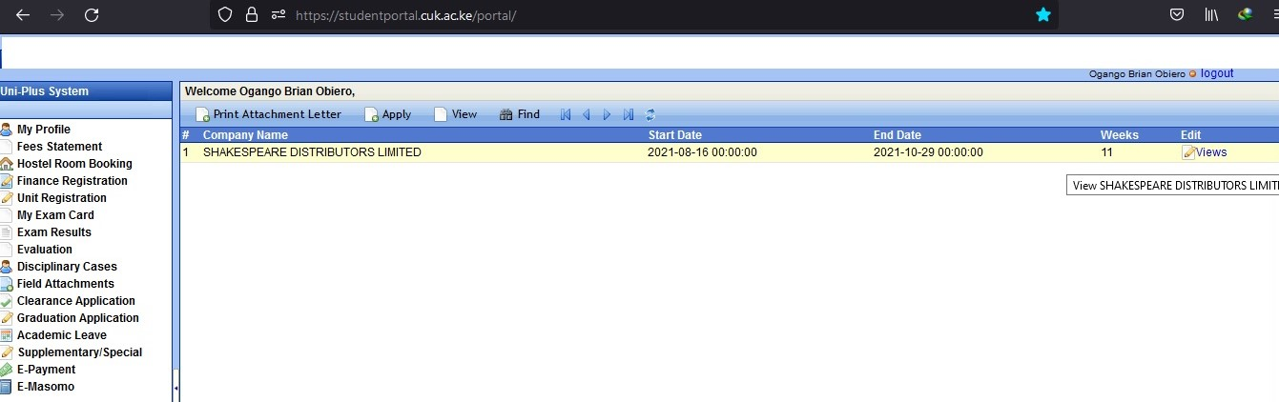

Step 5: Once you begin attachment, you are required to fill an online logbook. You can be accessed by clicking on the “Views” button. It will open a page with the 12 weeks of attachment. Open each week by clicking “Manage Logbook” and fill the logbook at the end of every week. Ensure you save your details by clicking on “save logbook’’

Screen 6: Logbook & Attendance Management
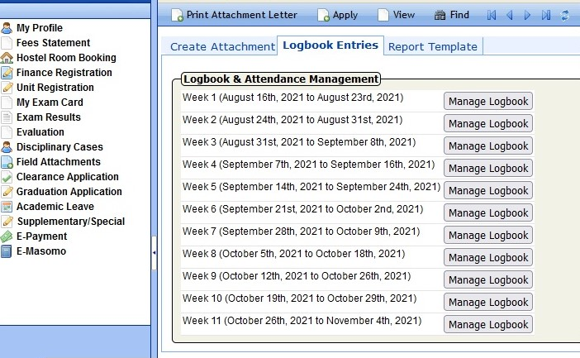
Screen 7: Logbook Entries
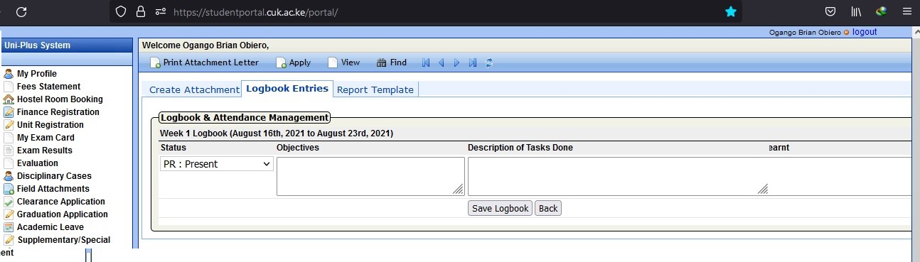

Step 6: At the end of the 12th week of attachment, open the “reporting template’’ and click on “save”. This will auto-generate your attachment report.

Screen 8: Report Template
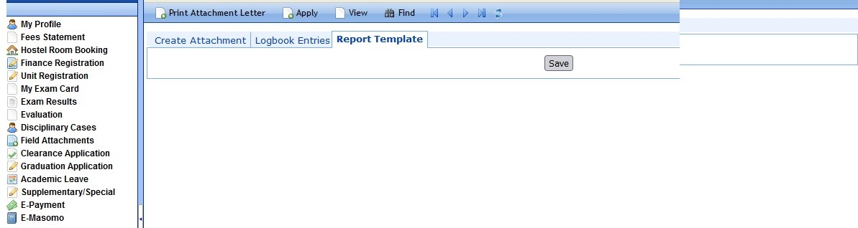

NB: In case of any challenges, contact us via dacsis@cuk.ac.ke. Only students who will have updated attachment details by 31st October, 2021 will be assessed.

D. K. MUTHONI,
DIRECTOR, DACSIS.

